**Do children appreciate parallels in the means/outcome distinction across semantic fields?**

How do we break down representations of events to encode them in a linguistic channel? Across languages, most verbs encode either Outcome (e.g. what happens, crossing the floor) or Means (e.g. how it happens, by dancing) of an event, but not both (cf. Talmy, 1985). Havasi et al. (2014) showed these biases are not fixed but malleable – when adults and 4-6yos learn several novel verbs in a row with path meanings (*rise, cross*), they begin to guess subsequent novel verbs will refer to path as well. For adults, these biases are very abstract: Geojo (2015) showed that after adults learned a Path bias for motion events, they more strongly preferred Outcome verbs for change-of-state scenes as well (see Table 1); the same is true in the reverse direction (from change-of-state to motion). Accomplishing this requires some kind of very general representation of events that can account for *hitting* (action) being more like *running* (manner) than like *entering* (path).

Where do these representations come from? Pre-linguistic infants are sensitive to a non-linguistic means/outcomes distinction (Phillips & Wellman, 2005; Woodward, 1998, Gergely et al. 2002). It is possible this early conceptual framework provides a foundation for early abstraction in verb semantics. To test this hypothesis, we adapt the training task used in Havasi et al (2014). Over a series of eight sequences, 4-6-yo children (N=19, study ongoing) were presented with a repeating learning sequence:

1. Bias: A word/event pairing is presented (e.g. hammer-flat), then children choose between events maintaining either Means (hammer-open) or Outcome (comb-flat).
2. Training: 3 additional events labeled with the same word maintain one aspect of the event (e.g. poke/pat/crowbar-flat)
3. Test: 2 new events matching either Means (hammer-crush) or Outcome (pry-flat)

Our key interest is ***not in the learning of individual verbs*** (3), but in the *biases* that children develop over the course of learning the verbs (i.e. bias measured at step 1). We ask (a) if children’s verb biases are also malleable in the change-of-state domain and (b) whether biases can extend between domains, relying on an abstract means/outcome distinction (Figure 1). Children learn within-domain biases quickly, making significantly different guesses after exposure to either Action or Effect verbs (X2=12.20, p<0.001)[1]. To test crossover, we then continue with bias-only trials in the Manner/Path domain. We see the expected pattern: after learning change-of-state verbs referring to Effect, children are more likely to guess a new Motion event verb refers to Path (X2=4.828, p<0.05).

It is now becoming possible and critical to ask how and in what form children gain access to conceptual/semantic representations that underlie language. These results suggest that children’s verb meanings draw on very abstract lexical semantics, which may be related to fundamental cognitive representations available to infants.

Word count: 492

Table 1

|  |  |  |
| --- | --- | --- |
| Semantic field | Verb types | |
| Change-of-state events | Action (hammering, hitting) | Effect (breaking, melting) |
| Motion/Spatial events | Manner (running, skipping) | Path (ascending, entering) |
| **Proposed abstract categories** | **Means** | **Outcome** |

References

Figure 1: Within- and Across-domain biases: Children who learn Effect verbs develop Effect biases and then maintain a Path bias in the extension phase. (Error bars represent 95% confidence intervals around the mean.)

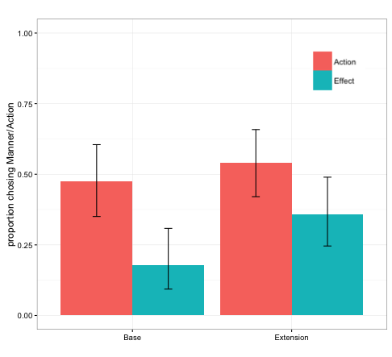

Talmy, L. (1985). Lexicalization patterns: Semantic structure in lexical forms. *Language Typology and Syntactic Description*, *3*, 57–149.

Shafto, C. L., Havasi, C., & Snedeker, J. (2014). On the plasticity of semantic generalizations: Children and adults modify their verb lexicalization biases in response to changing input. *Developmental Psychology*, *50*(3), 794–808.

Geojo, A. (2014). *Breaking and Entering: Verb Semantics and Event Structure* (Doctoral dissertation). Harvard University.

Phillips, A. T., & Wellman, H. M. (2005). Infants’ understanding of object-directed action. *Cognition*, *98*, 137–155.

Woodward, A. L. (1998). Infants selectively encode the goal object of an actor’s reach. *Cognition*, *69*, 1–34.

Gergely, G., Bekkering, H., & Király, I. (2002). Developmental psychology: Rational imitation in preverbal infants. *Nature*, *415*(6873), 755–755.

1. All significance testing is performed by comparing a logistic regression mixed model with Condition as a fixed effect and individual subject random intercepts. P values reflect comparisons between this model and the model lacking the fixed effect of Condition.